Full title [Title]
Title First name Last name¹, Title First name Last name², Title First name Last name³ [style: Authors]
¹ Affiliation name (in the order: Research lab, Department, Faculty, University), Country, e-mail [style: Affiliations]
² Affiliation name (in the order: Research lab, Department, Faculty, University), Country, e-mail [style: Affiliations]
³ Affiliation name (in the order: Research lab, Department, Faculty, University), Country, e-mail [style: Affiliations]

ABSTRACT

These guidelines provide instructions to format your abstract. It is advised to write directly into template and use the formatting styles, indicated in light grey that should be deleted before final submission. The abstract should be a single paragraph and should follow the style of structured abstracts, but without headings: 1) Background: Place the question addressed in a broad context and highlight the purpose of the study; 2) Aims and objectives of the study, 3) Methods: Describe briefly the main methods applied. 4) Findings: Summarize the article's main findings; and 5) Conclusion and implications: Indicate the main conclusions or interpretations. The abstract should be submitted in the Word document (.doc or .docx) and should not exceed 250 words. Please avoid direct quotations, abbreviations, acronyms, and references in your abstract. [Abstract body]
Following guidelines provide instructions to format your full paper, specifically on the way how text should be formatted, table and figures captioned and references cited. The conference proceedings will be published in an electronic format. The paper should be submitted in the Word document (.doc or .docx) and shall be written in accordance with instructions of Urban Morphology Paper Submission Guidelines.
Keywords: three, to, five, keywords [Keywords]
title]

INTRODUCTION [Heading 1]
The introduction provides sufficient background information for the reader to understand and place the study in a broad context. It also supplies a rationale for the study and highlights why it is important. It should define the purpose of the work and its significance, including specific hypotheses or research questions. It is expected from authors to reflect on the current state of the research and provide references to key publications. Introduction section should end with a description of the remainder of the paper and its structure. [Text body]

Introduction subsection [Heading 2]
In case you need subsections, please use Heading 2 and Heading 3 styles for their title.

Introduction subsection [Heading 3]
No more than three levels of headings should be used. When mentioning and referencing specific work, please use author and year in parenthesis (Surname, 2003). If you are citing several works at the same time, all relevant surnames and years should be included in parenthesis chronologically (Surname, 2010; Surname 2014). Citations of works by two authors should have ‘and’ (not an &) between the names (Surname and Surname, 2015). Citations of works by three or more authors should have the first author followed by et al in italics (Surname et al., 2021). Furthermore, “When you include a quote in the text, this should be in italic, contained quotation marks and listing in the reference author(s), year of publication, as well as page number or page range” (Surname, 2020: 5-8). [Text body]

METHODOLOGY [Heading 1]
The methodology section of your paper describes how your research was conducted and should be described with sufficient detail to allow others to replicate and build on published results. All new methods used in research should be described in detail while well-established methods can be briefly described and appropriately cited. Mention the full name and version of any software used and make clear whether computer code used is available. You should also clearly describe the data you have used. Illustrate your method and workflow with figures (in colours or black and white or tables. Remember that each figure included in your paper should be referred to in the text and numbered following the order of appearance (Figure 1). Figures must be inserted in the document as JPEGs, within the limits imposed by the page margins. Do not insert loose objects such as arrows, lines or text boxes. [Text body]

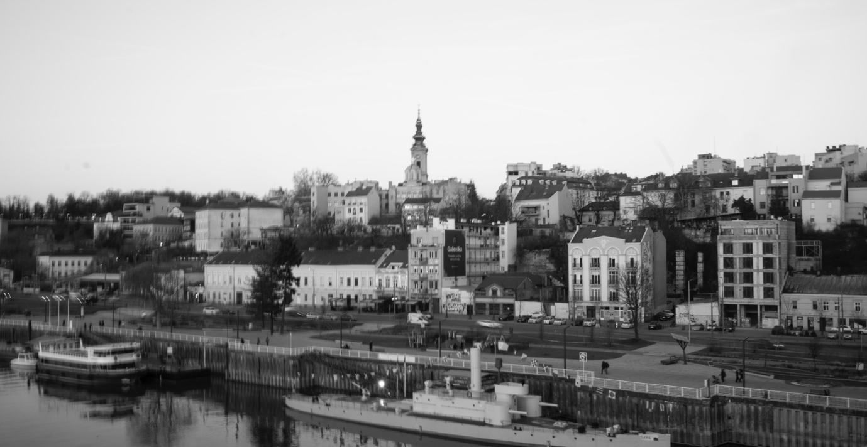

Figure 1. Always include a caption and source below your image. Belgrade, photo credit: Djordjević Aleksandra [Figure caption]
There are several rules that apply to tables and figures. Firstly, text should provide references to all tables and/or figures and numbered following the order of appearance. For example, As shown in Table 1. Tables should be created within the MS Word document and not imported as images and should fit within page margins. Please ensure that tables do not split over more than one page. It is highly recommended to avoid endnotes and footnotes. [Text body]

Table 1. Always include a caption and source above table. Table showing a set of observations and values. [Table caption]
Field | Field | Field | Field [Table field]
Entry Field | Value | Value | Value [Table body]
Entry Field | Value | Value | Value [Table body]
Entry Field | Value | Value | Value [Table body]

RESULTS AND DISCUSSIONS [Heading 1]
Provide a concise, clear and precise description of the results and their interpretation. Results and discussions can be presented as a same section or as separate sections or sub-sections. You may use tables, drawings, figures and diagrams to illustrate your findings. Make sure to dedicate enough place for discussing your results and to reflect on how they can be interpreted in perspective of previous studies and of the working hypotheses/research questions. The findings and their implications should be discussed in the broadest context possible and limitations of the work highlighted. [Text body]

CONCLUSIONS [Heading 1]
The paper should be completed with your conclusions. Future research directions may also be mentioned. Please note that every reference cited in the text should also be present in the reference list and vice versa. Citations should follow the Harvard referencing style, which is also used in the Journal of Urban Morphology. References in the reference list section should be arranged first alphabetically and then further sorted chronologically, using the appropriate pre-defined paragraph style. [Text body]

Acknowledgements [Heading 1]
In this section you can acknowledge any support given which is not covered by the author contribution. This may include funding source (funder’s name and grant information), technical or immaterial support, or donations in kind (e.g., materials used for experiments) and up to 150 words may be included. [Text body]

References [Heading 1]
Biddle, M. and Hill, D. (1971) ‘Late Saxon planned towns’, Antiquaries Journal 51, 70–85. doi.org/10.1112/13578 [Reference list]
Whitehand, J. W. R., Gu, K., Conzen, M. P. and Whitehand, S. M. (2014) ‘The typological process and the morphological period: a cross-cultural assessment’, Environment and Planning B: Planning and Design 41, 512-33. [Reference list]
Conzen, M. R. G. (1968) ‘The use of town plans in the study of urban history’, in Dyos, Urban Morphology follows the ethical standards of the Committee on Publication Ethics (COPE). H. J. (ed.) The study of urban history (Edward Arnold, London) 113–30.
English Heritage (2010) Understanding place: an introduction (http://www.english-heritage. org.uk/Publications) accessed 23 June 2010.
Hillier, B. (1996) Space is the machine (Cambridge University Press, Cambridge).
Kropf, K. S. (1993) ‘An inquiry into the definition of built form in urban morphology’, unpublished PhD thesis, University of Birmingham, UK.
Thompson, F. M. L. (ed.) (1982) The rise of suburbia (Leicester University Press, Leicester).

